Secure Document Intelligence - Proof of Concept (POC)
Executive Presentation Document
AI-Powered Document Search, Question Answering & Summarization Platform

Executive Summary
Secure Document Intelligence is a local-first AI platform that enables users to upload documents, perform semantic search, ask questions, generate summaries, and retrieve source-backed information while keeping all data within the organization's environment.

Business Problem
Organizations spend significant time manually searching PDFs, policies, contracts, reports, and technical documents. Critical information is often buried within hundreds of pages.

POC Scope
The current implementation demonstrates document ingestion, vector search, document-specific Q&A, summarization, source attribution, and document lifecycle management. Q&A capabilities are functional but remain under active improvement as part of the POC roadmap.

POC Walkthrough

Application Home Screen & Upload Interface
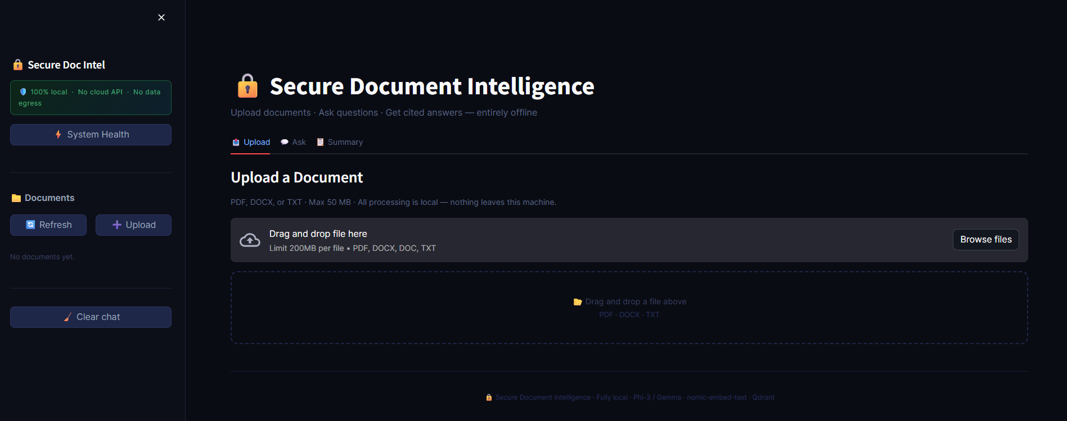
Application Home Screen & Upload Interface

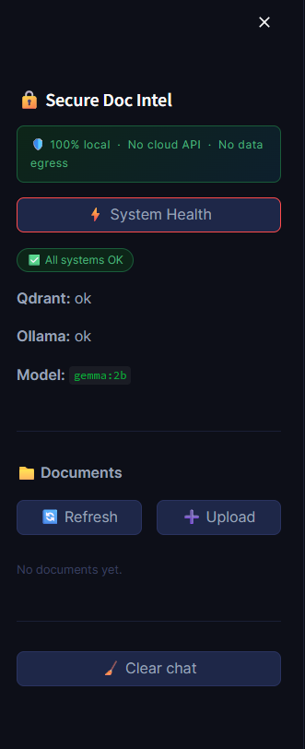
System Health Monitoring

System Health Monitoring

Document Upload Process
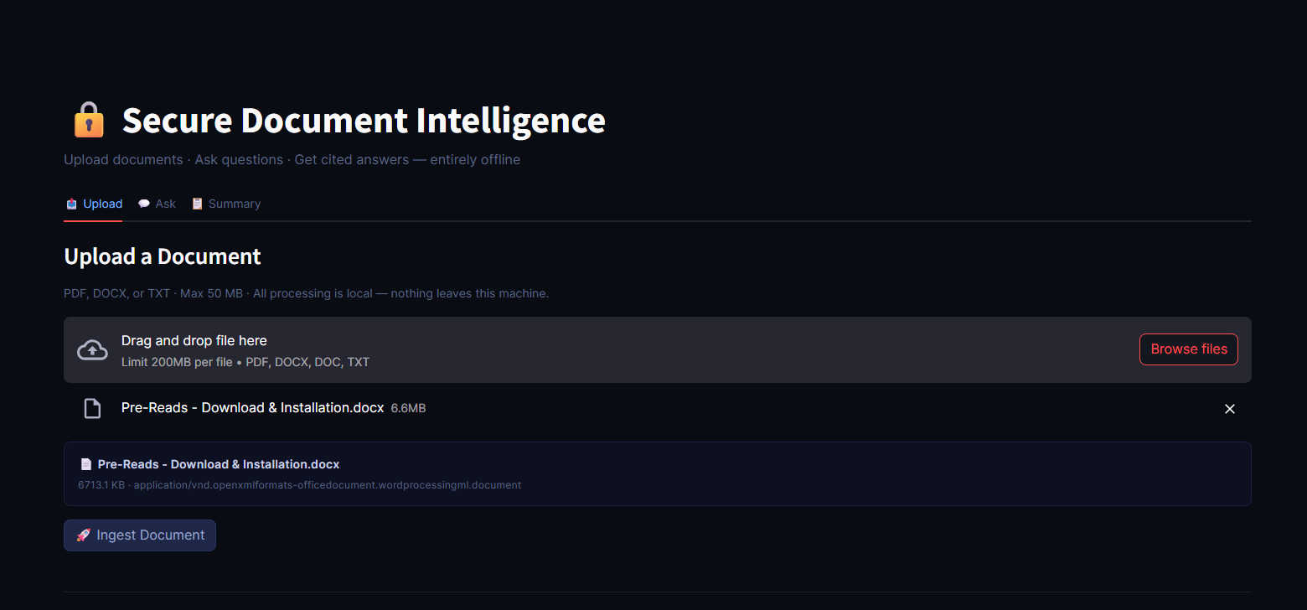

Document Successfully Ingested
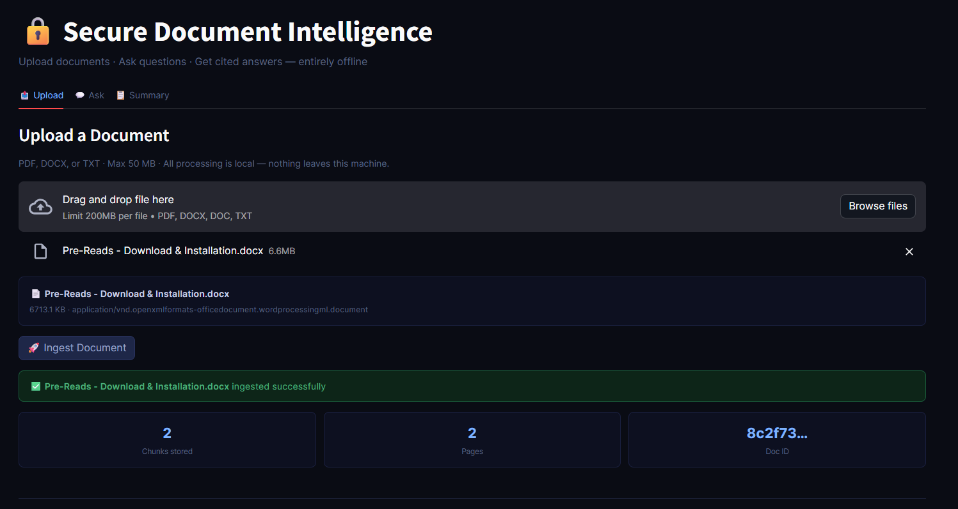

Document Repository View
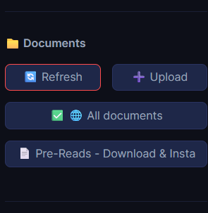

Question & Answer Workflow
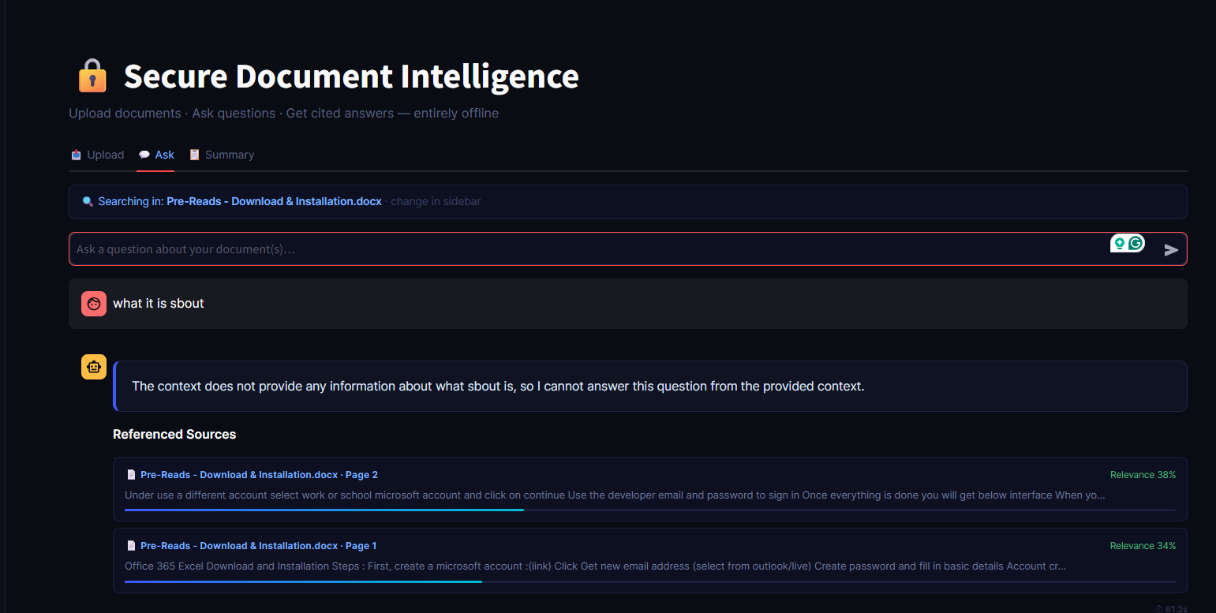

Document Selection & Management
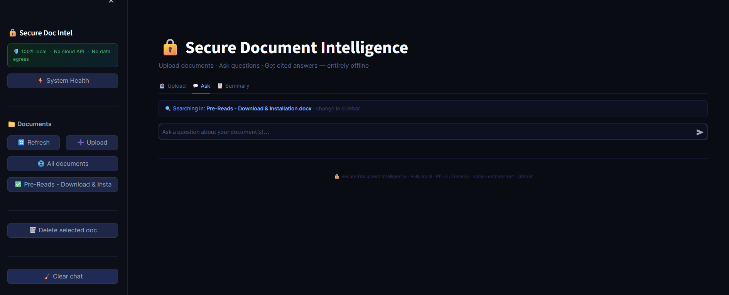

Document Summary Generation
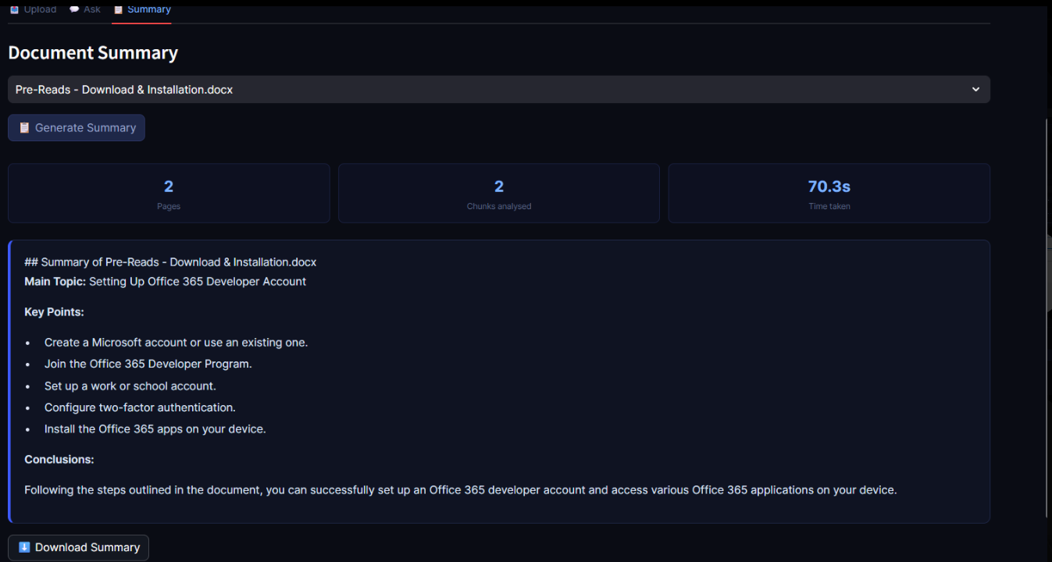

Downloaded Summary Output
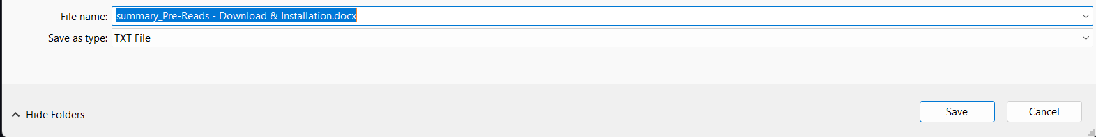

After Delete document - Document section

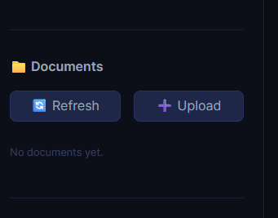

Current Features
• Upload PDF, DOCX and TXT documents
• Local document processing
• Qdrant vector storage
• Semantic retrieval
• Document-specific Q&A
• Source citations and relevance scores
• Document summaries
• Downloadable summaries
• System health monitoring
• Document deletion and chat reset

Technical Architecture
Frontend: Streamlit
Backend: FastAPI
Vector Database: Qdrant
Embeddings: nomic-embed-text
LLM: Gemma/Phi-3 via Ollama
Language: Python

Known POC Limitations
• Question answering quality is functional but not yet production-grade.
• General document understanding questions require prompt optimization.
• Multi-document reasoning is not yet implemented.
• Advanced citation formatting and confidence scoring require enhancement.

Future Roadmap
Phase 1:
- Improve prompt engineering and answer quality
- Better document overview responses
- Enhanced source citation formatting
Phase 2:
- Multi-document search
- OCR support for scanned PDFs
- Excel and PowerPoint ingestion
- User authentication and RBAC
Phase 3:
- Agentic workflows
- Compliance validation
- Document comparison
- Executive insight generation
- Analytics dashboard

Conclusion
The POC successfully demonstrates a secure, local-first document intelligence platform capable of document ingestion, semantic retrieval, summarization, and AI-assisted knowledge discovery. The next phase focuses on improving answer quality and enterprise-scale capabilities.

